**Box Model : Konsep**

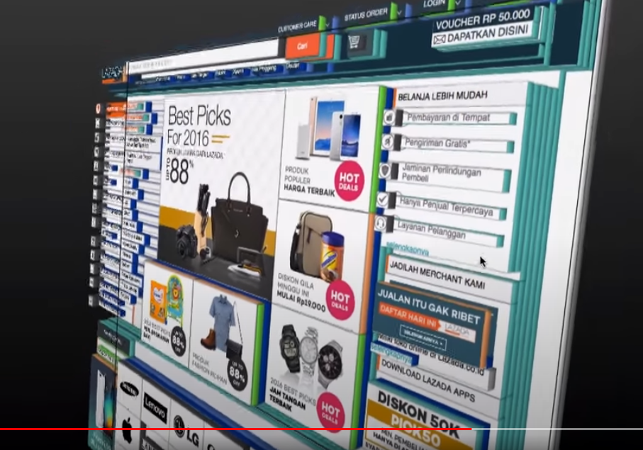

Fitur Mozzila Firefox : 3d View.

**Margin**

**Padding & Border**

**Alternatif**

**CSS RESET**

**Reset memungkinkan programmer untuk mendapatkan kendali penuh kepada HTML/css**

**FLOAT**

**CLEAR**

